Project documentation for Po3D – Oliver Thomson

**Research and planning:**

I have aimed to hit the mark of a pretty traditional pirate scene. A lone ship in the middle of a vast ocean. My environment is very much inspired by sea of thieves.

**References:**

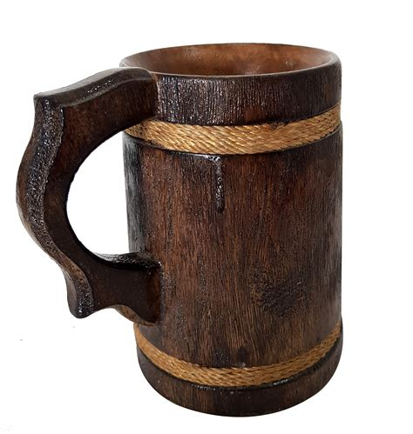

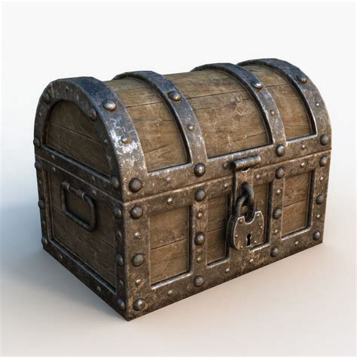

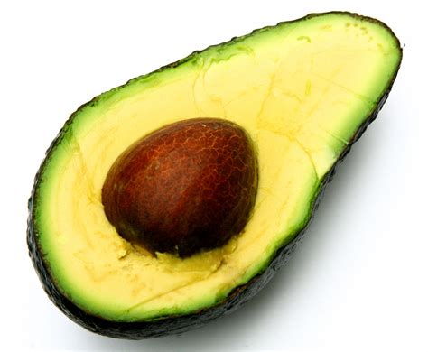

**Inventory of unity assets:**

|  |  |
| --- | --- |
|  | My player model and controller is from the unity starter assets 3rd person controller  [Starter Assets - ThirdPerson | Updates in new CharacterController package | Essentials | Unity Asset Store](https://assetstore.unity.com/packages/essentials/starter-assets-thirdperson-updates-in-new-charactercontroller-pa-196526) |
|  | My cup is modelled in maya and textured with smart materials from substance painter default materials |
|  | My chest is modelled in maya and textured with smart materials from substance painter default materials |
|  | My avocado is modelled in maya and textured with smart materials from substance painter default materials |